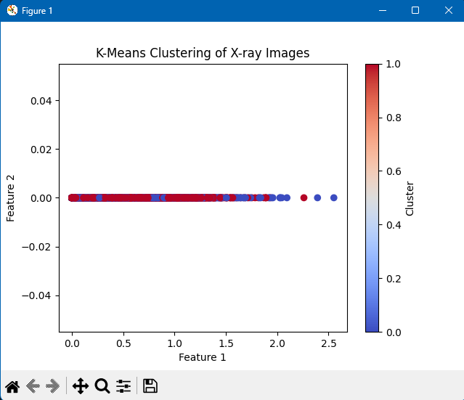K-Means Clustering of 5000 X-Ray Images